# Stanbic Ebiller Documentation

Ebiller is a general corporate billing platform that aims at easing you monthly bill payments.It is divided into

* Bank Side
* Payer side
* Biller Side

# Bank Side

This is the administrative panel for bank users

### Usage

**Login**

Bank users login with their NTKEN credentials

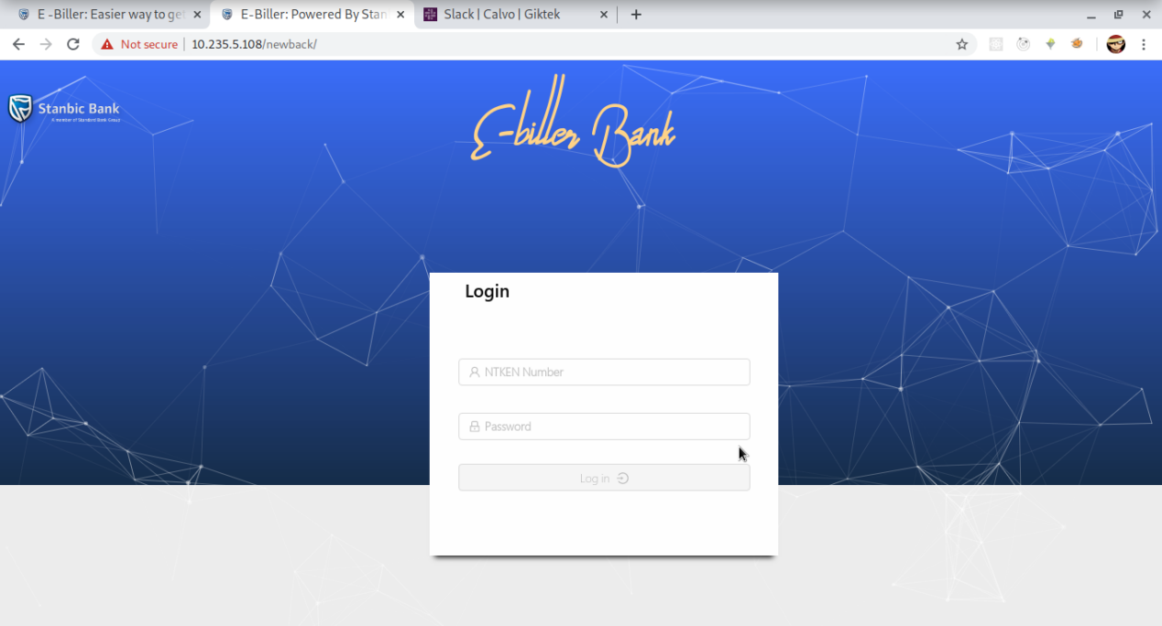

**Dashboard**

The bank dashboard has a summary of the accounts,service charge,number of exceptions ,total eslip amount, number of payers and number of billers.

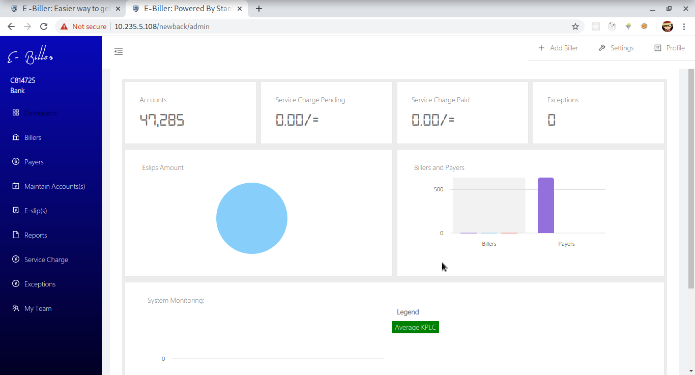

**Billers**

Billers are divided according to the status

* Active(Have completed registration and activated accounts)
* Pending(Registered but inactive accounts)
* Invited(have only invited)

Active Billers

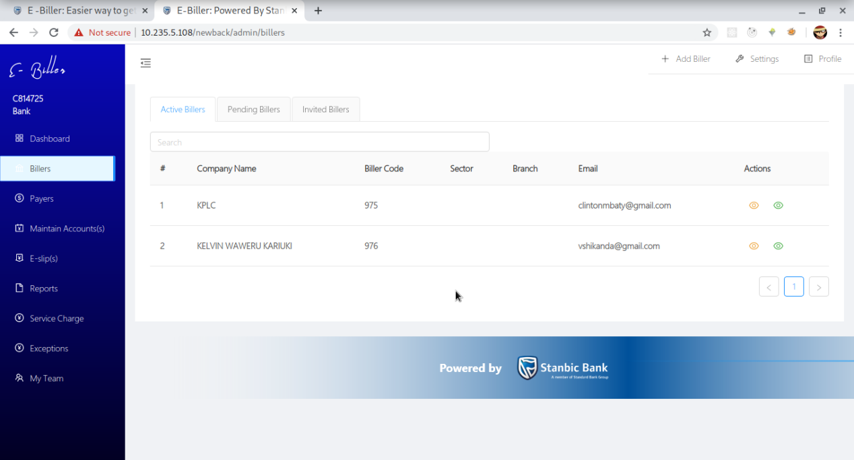

Pending Billers

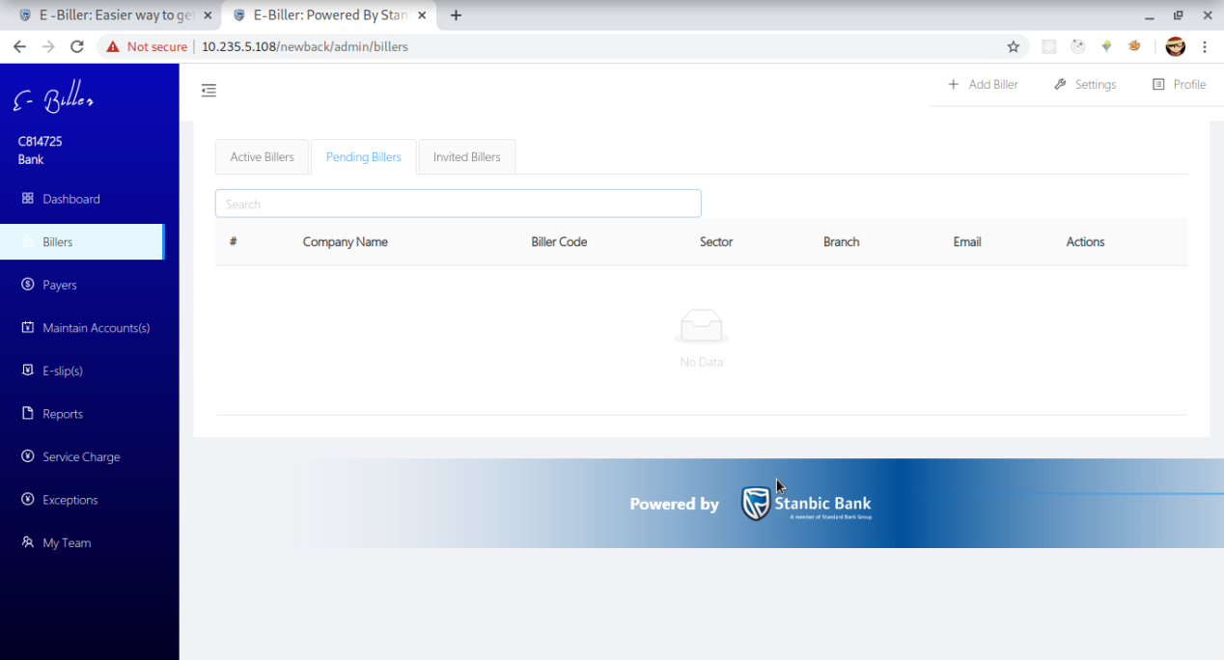

Invited Billers

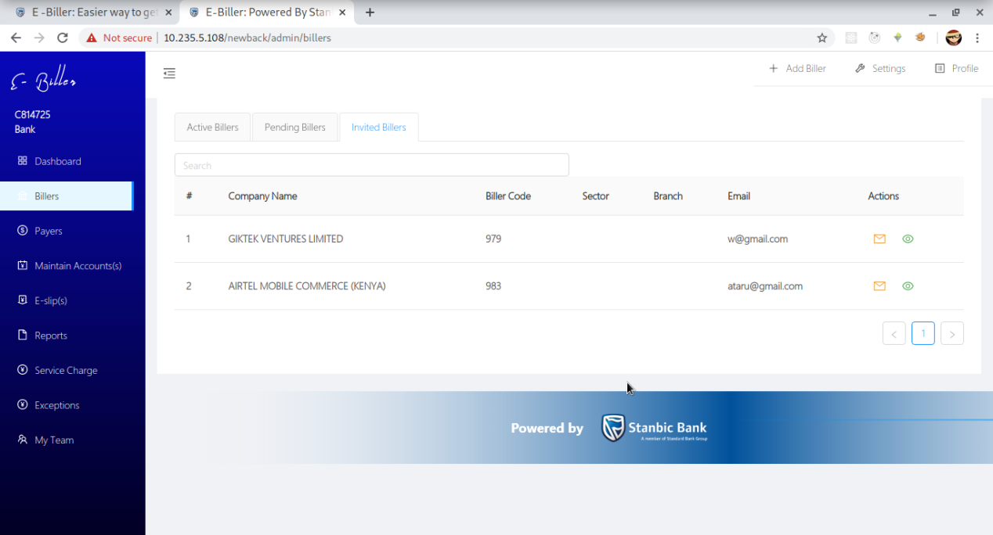

**Payers**

List of all active payers filtered by according to the biller

To get a list of payers you have to select a biller first then the click on the filter button

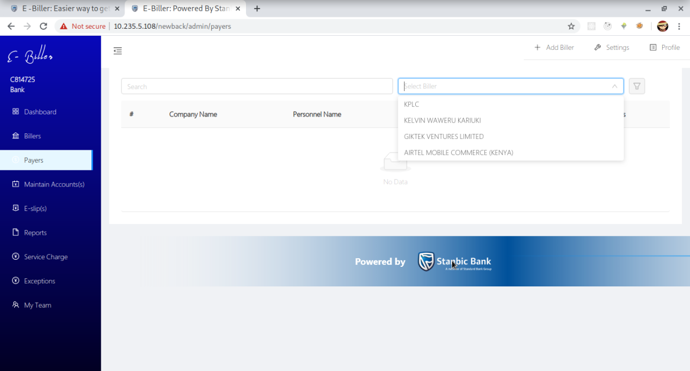

Payer List

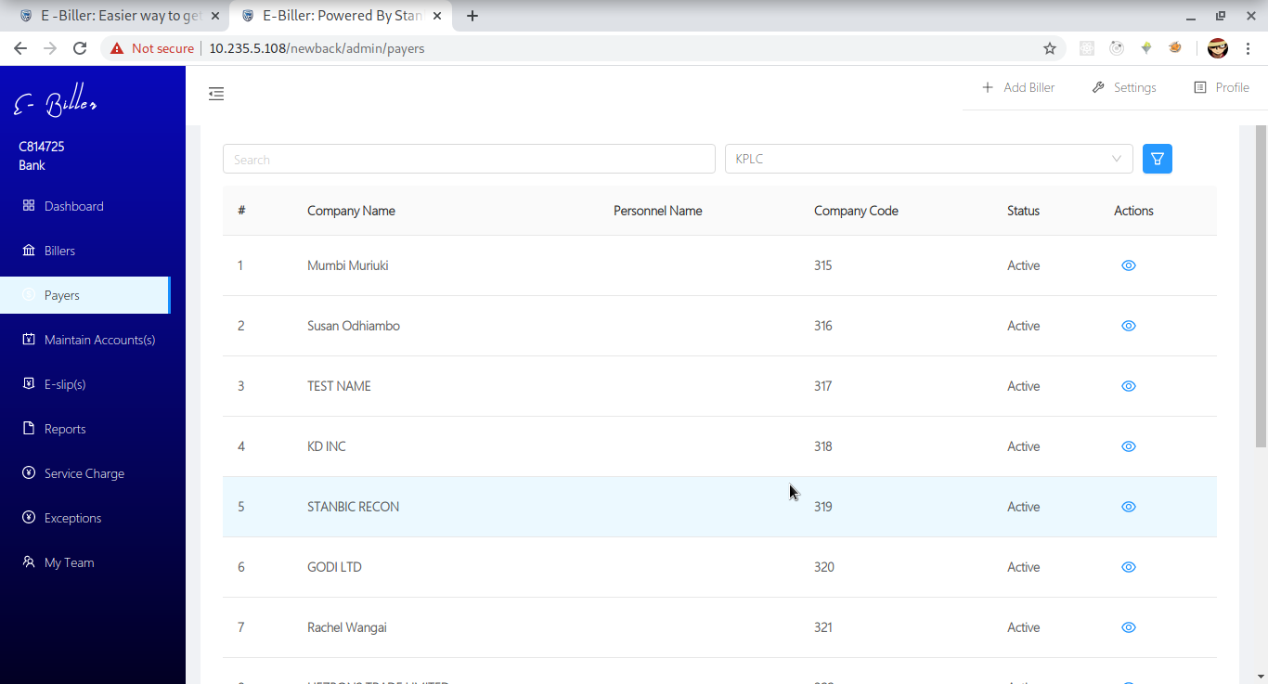

Payer Profile

You can view a payer’s profile by clicking on the blue eye icon

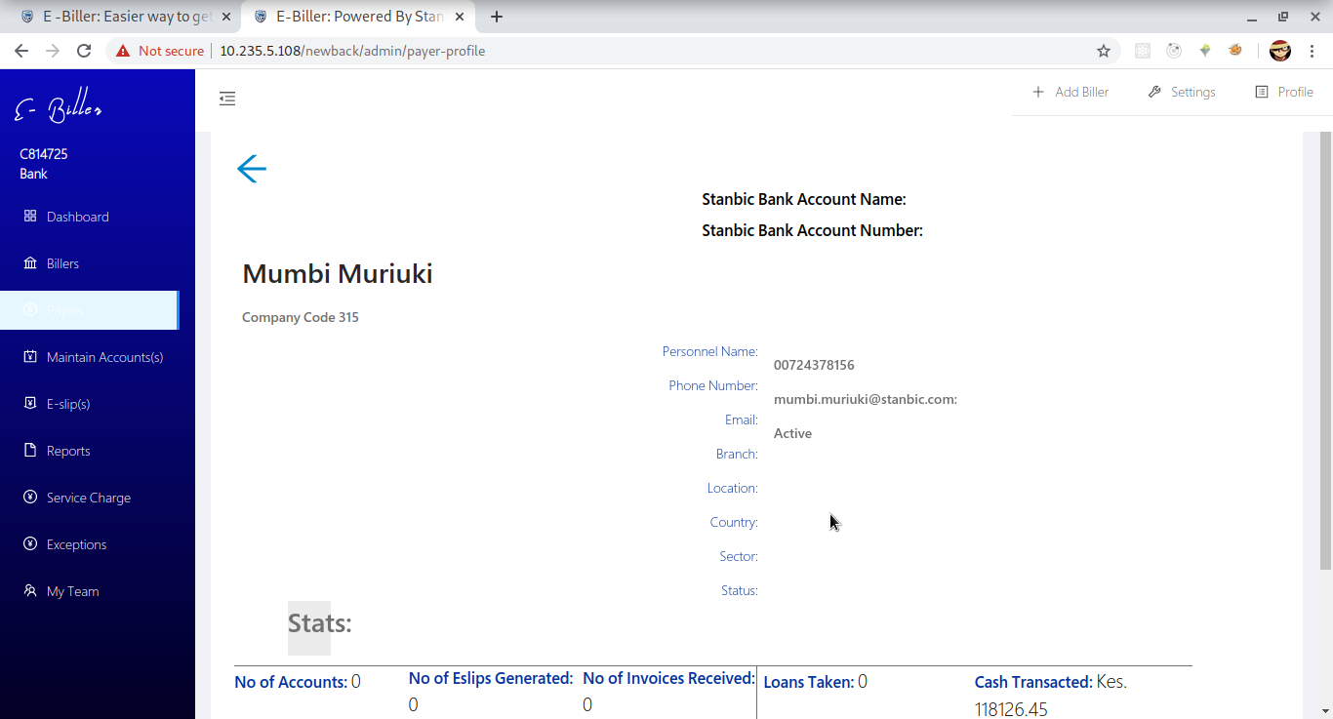

**Maintain Accounts**

The bank can manage accounts of a biller upon request

Management of the accounts is split into

* Adding new accounts

The first screen lists the accounts per biller.In order to get the list you have to select a biller and a payer then click the button to fetch

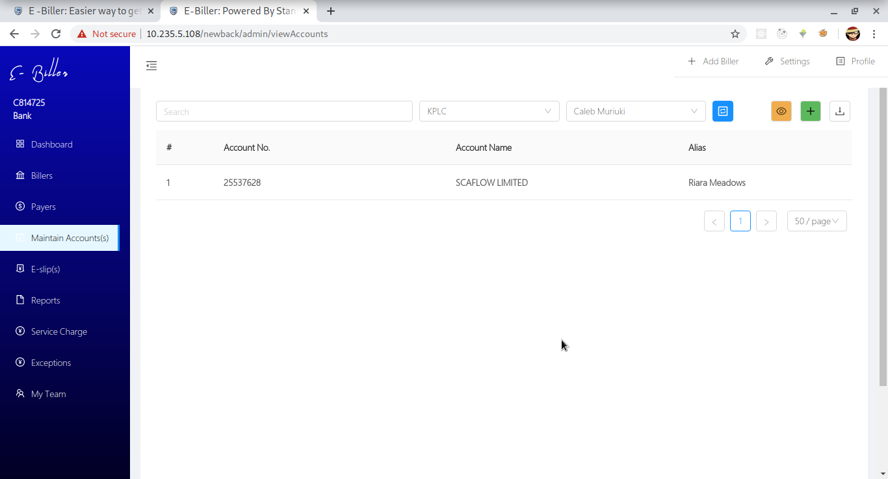

Adding Accounts

Accounts can be added by

* Uploading an excel file containing the accounts

To get the format of the required file you can download a sample by clicking on the download sample file button

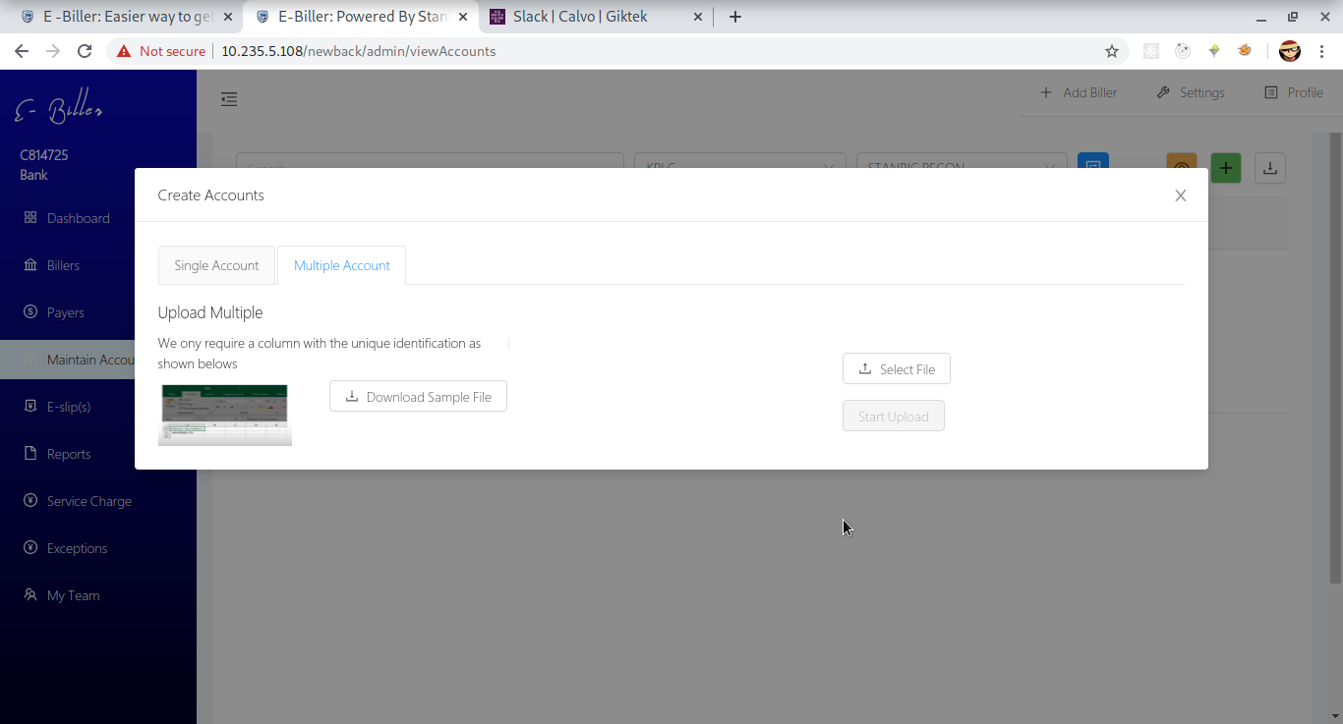

If the file is in a supported format the accounts are validated before being added to the selected payers profile

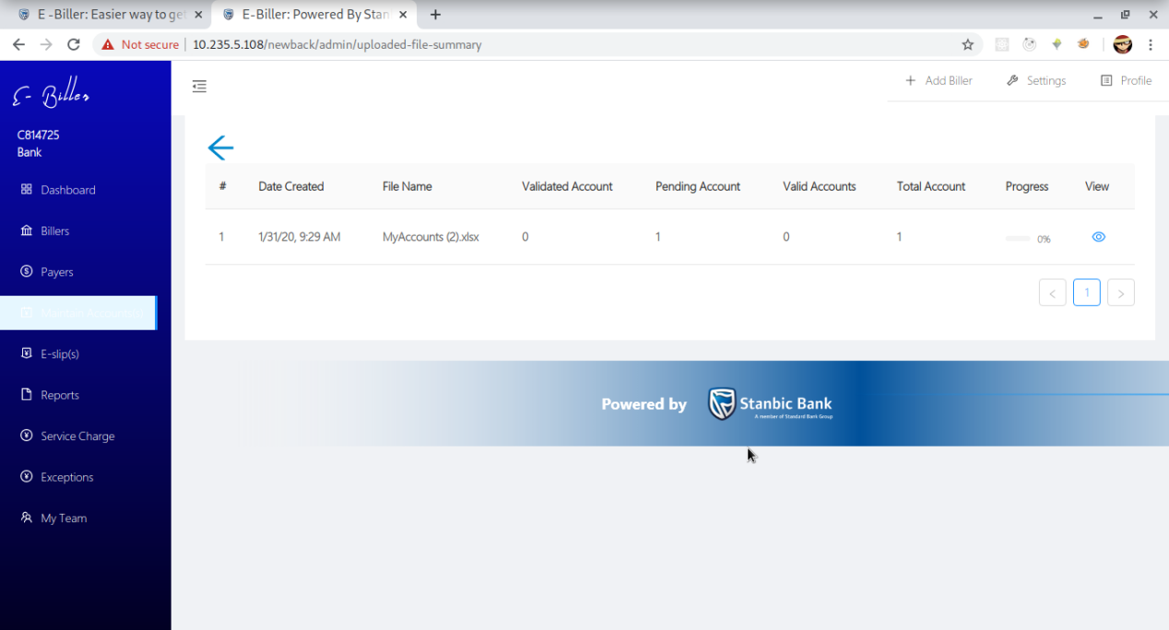

* Adding a single account by providing

1. Account Number to query against
2. Alias(Optional)

After adding the account number you validate it first then save it to your profile by clicking save

The account number will be used to fetch an account name and the amount due

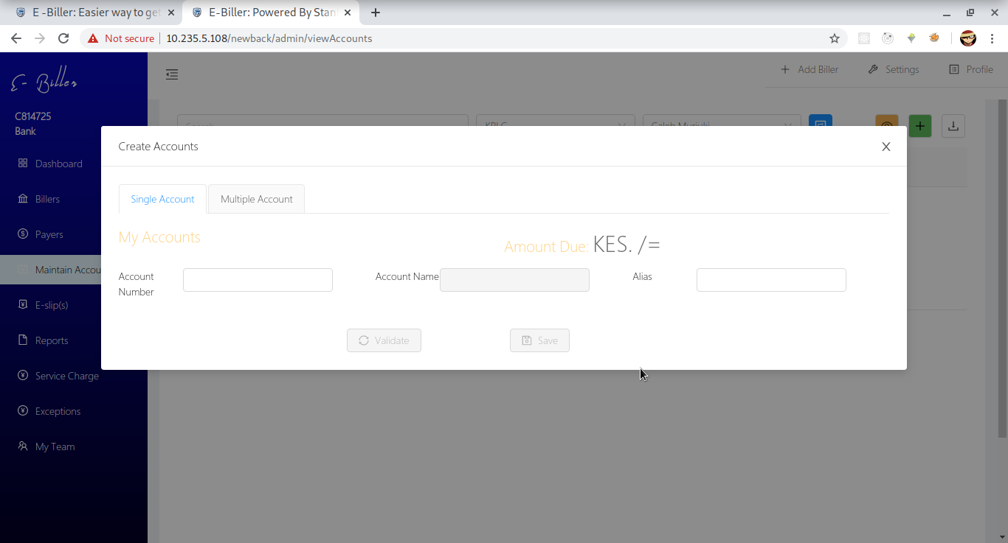

**Eslips**

***To view,create or perform any operation select a biller and a payer first***

Generate E slip

Can be generated by

* Selecting accounts that you want to add to the eslip

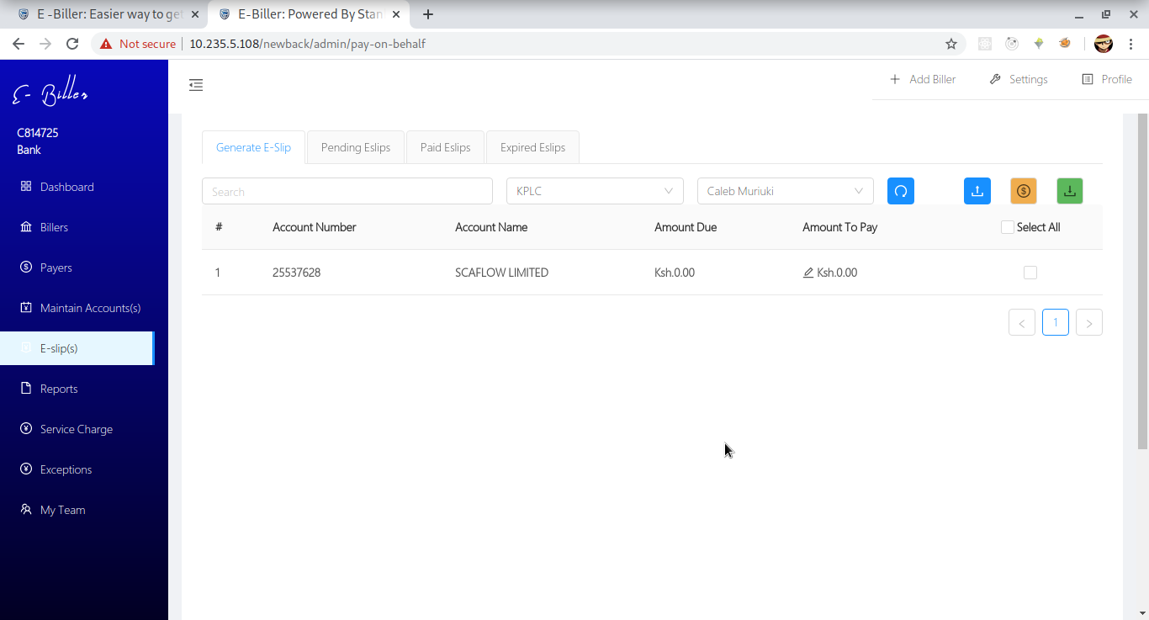

* Uploading a payment file

Find a sample file by downloading a sample file

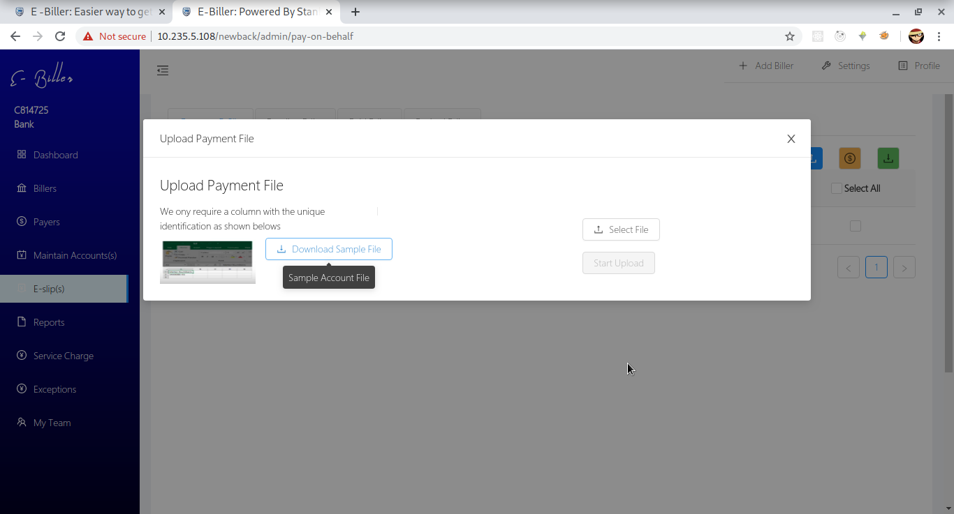

Pending Eslips

List of unpaid eslips

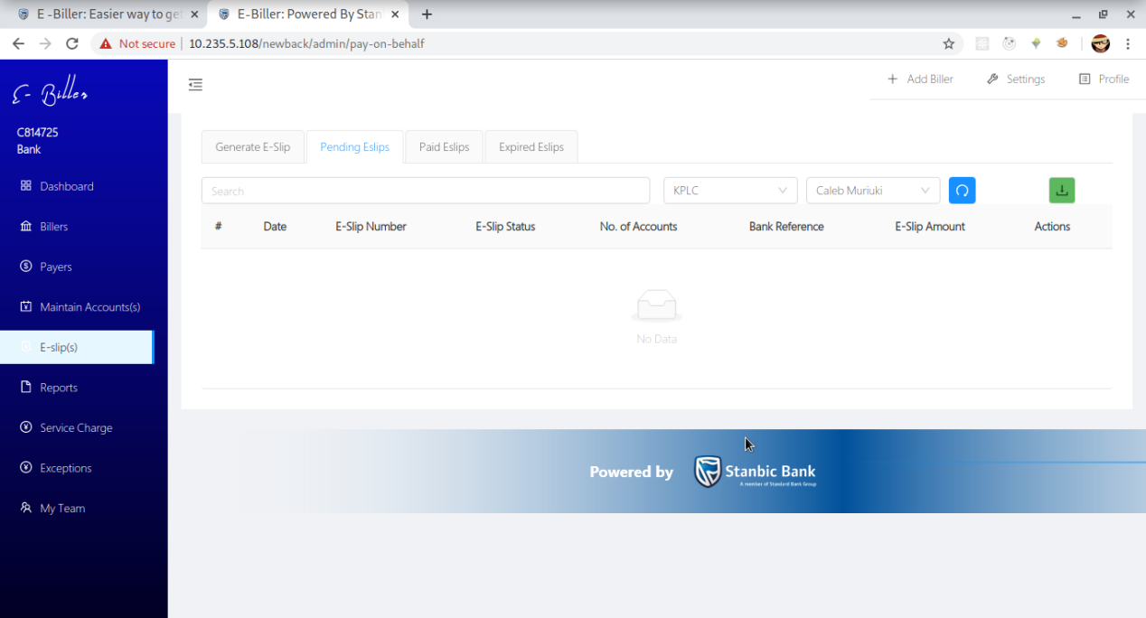

Paid Eslips

List of paid eslips

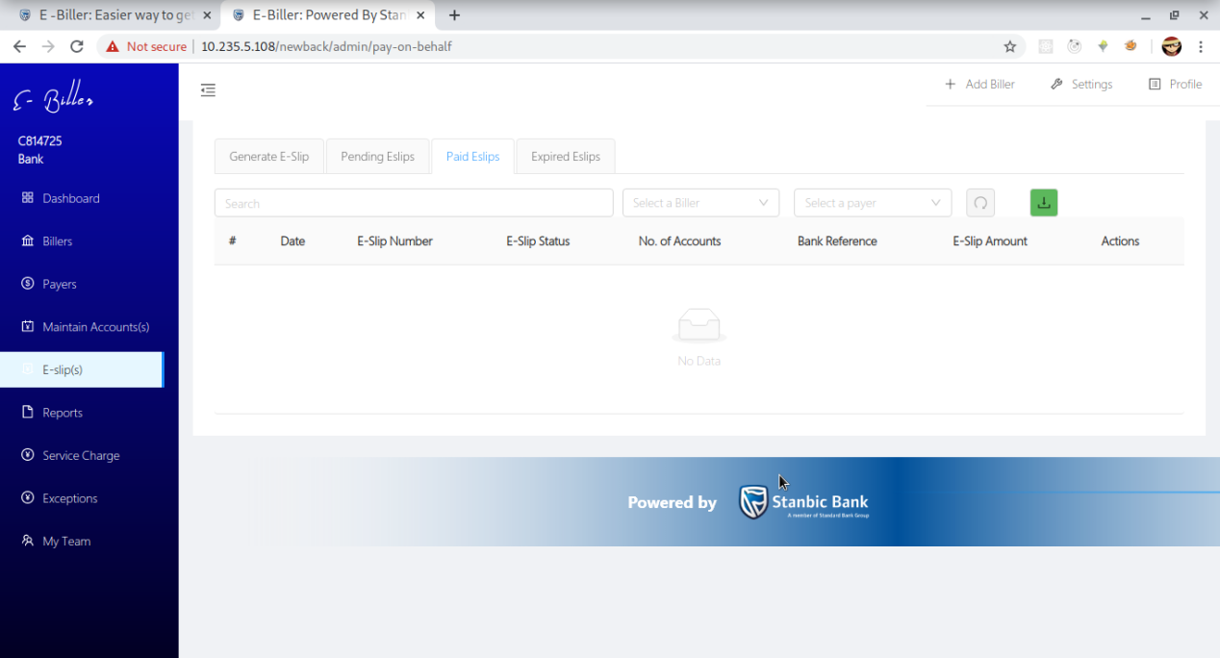

**Reports**

Provides a summary of the paid eslips according to the date range, biller and payer

The list is fetched once you click the the blue reconcile button.

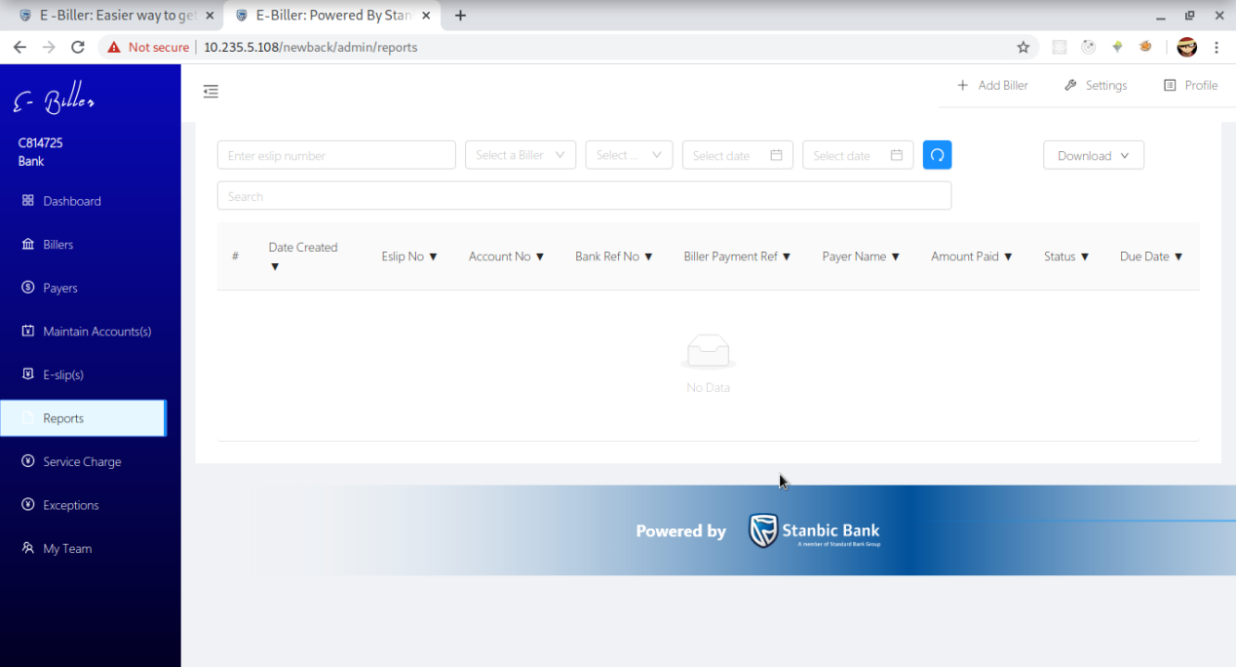

**My Team**

Option of managing the bank team members

You can

* Add new members
* Edit the current members
* Freeze/Lock a member
* Create a user group
* Edit a user group
* Delete a user group
* Manage roles per user group

List of the team members

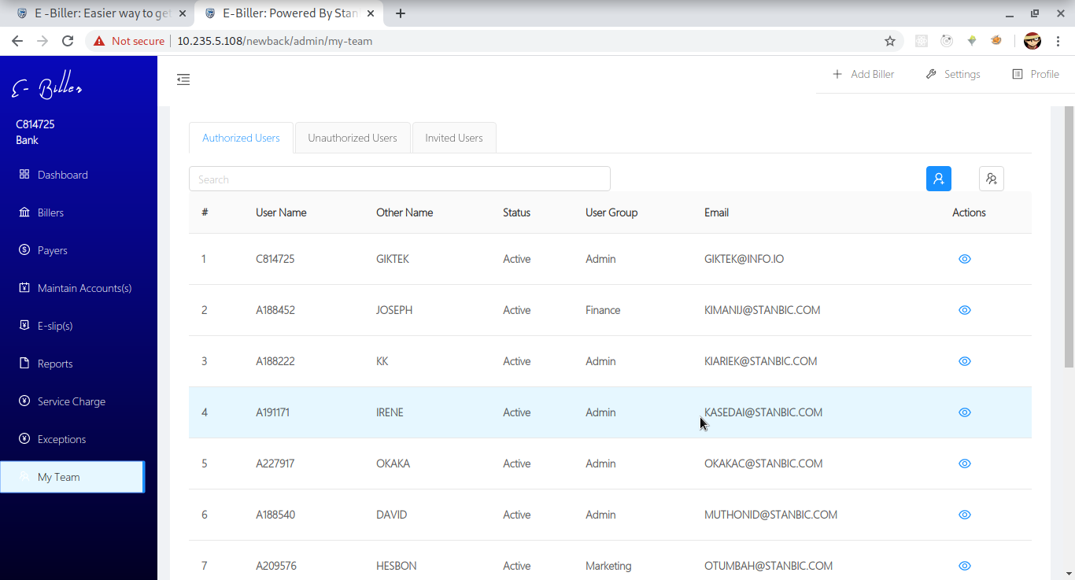

Adding a new team member

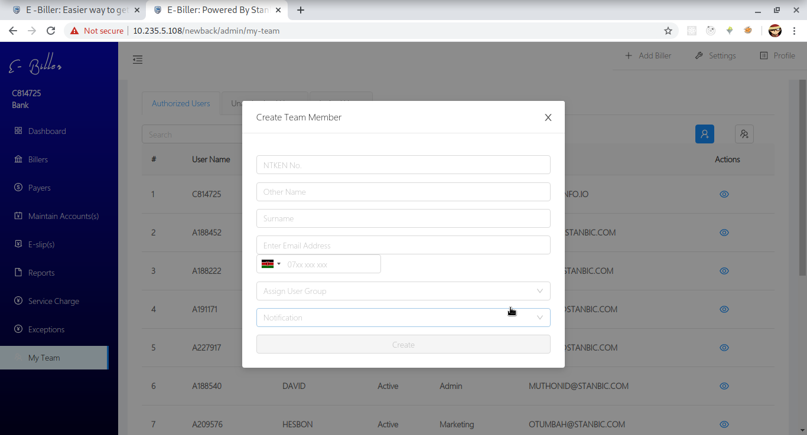

Editing a team member

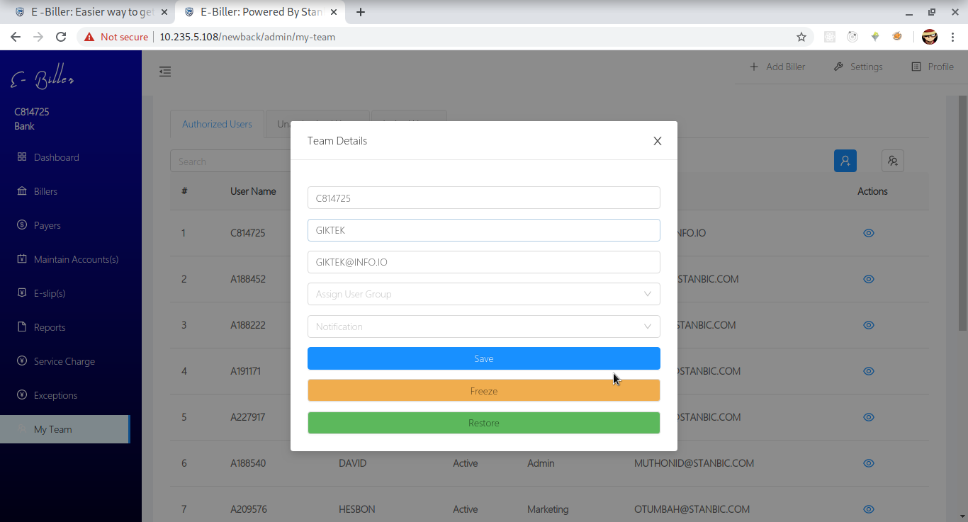

User groups

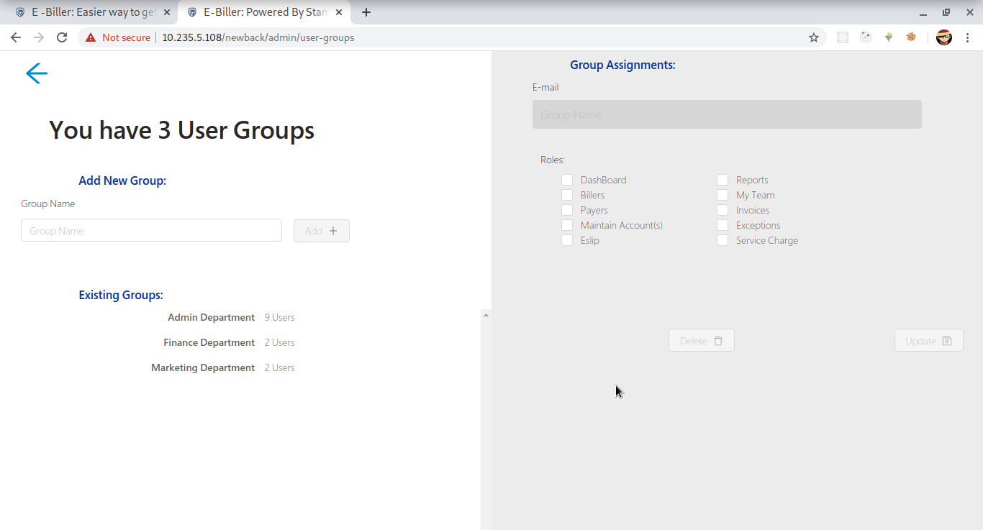

**Note**

* *Most buttons are disabled whilst some of the fields in the form are empty.Please fill those fields first*
* *Under eslips and maintain accounts the operations are tied to a specific biller and a specific payer.Kindly select each before attempting to perform any operation*

# Payer Side

## Usage

Client side

**Payer registration**

A payer is expected to register with an email address.

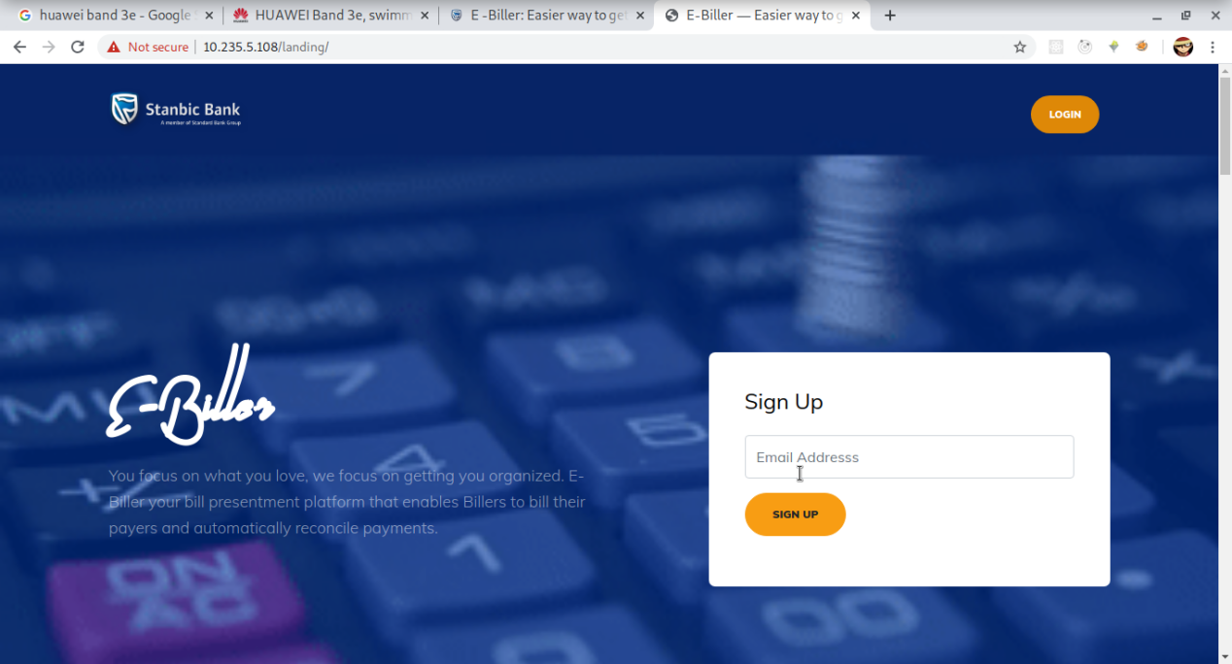

**Payer Login**

A payer logs in with the email and password

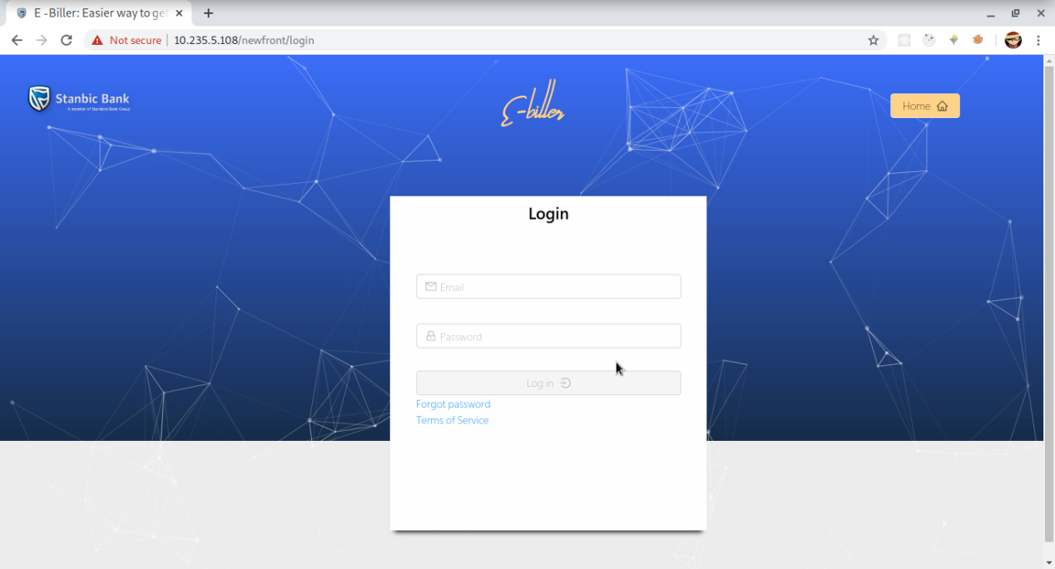

**View Billers**

List of available open billers

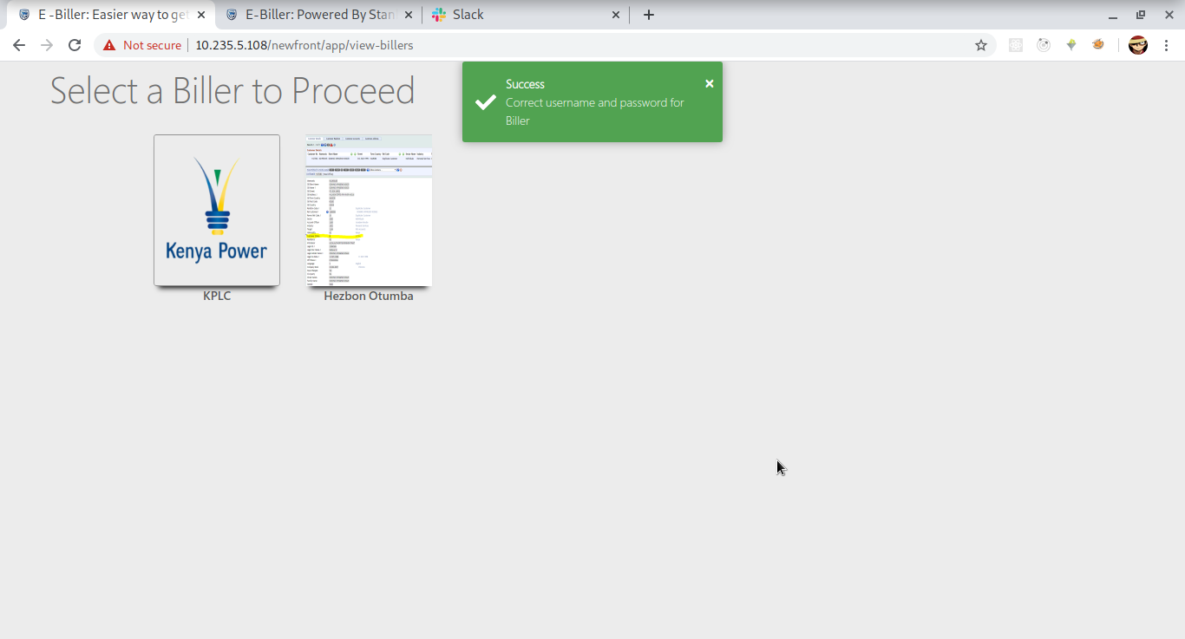

**Payer Biller Dashboard**

Has a summary of the accounts, amount due,summary of eslips and amount paid

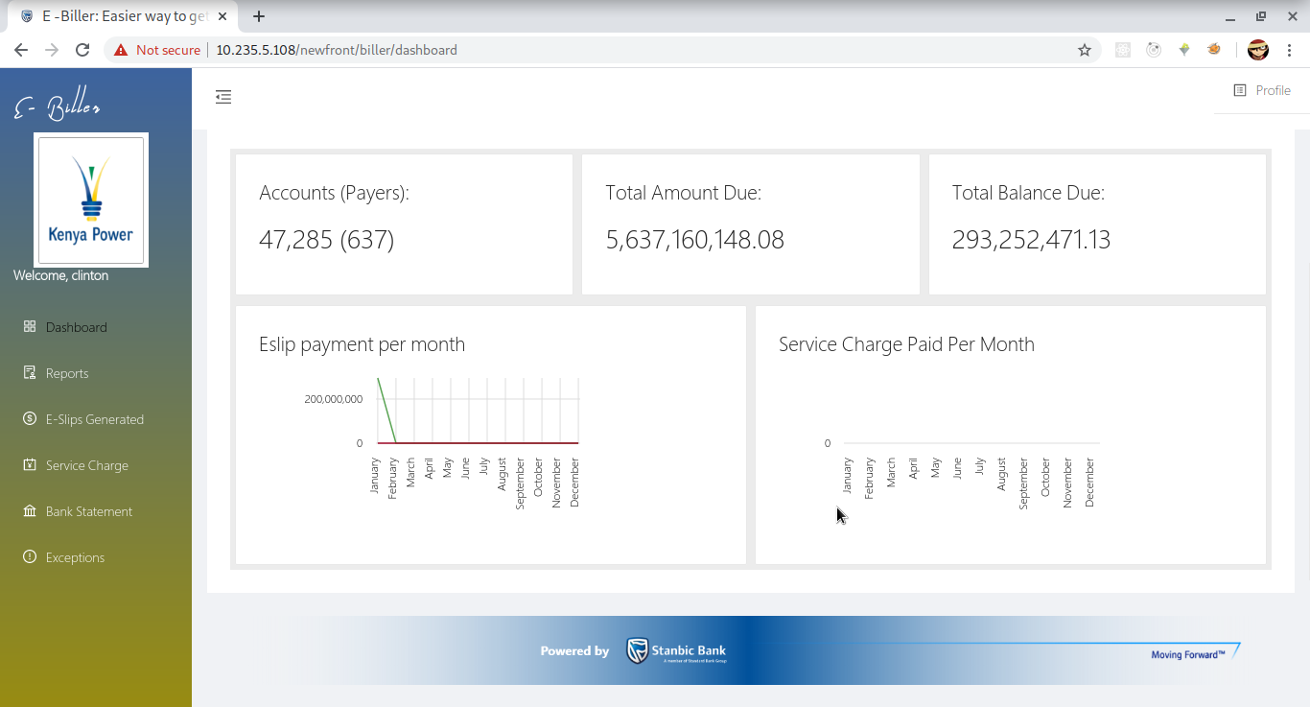

**Maintain Accounts**

Account administration by adding,editing and deleting accounts

Adding Accounts

By account number

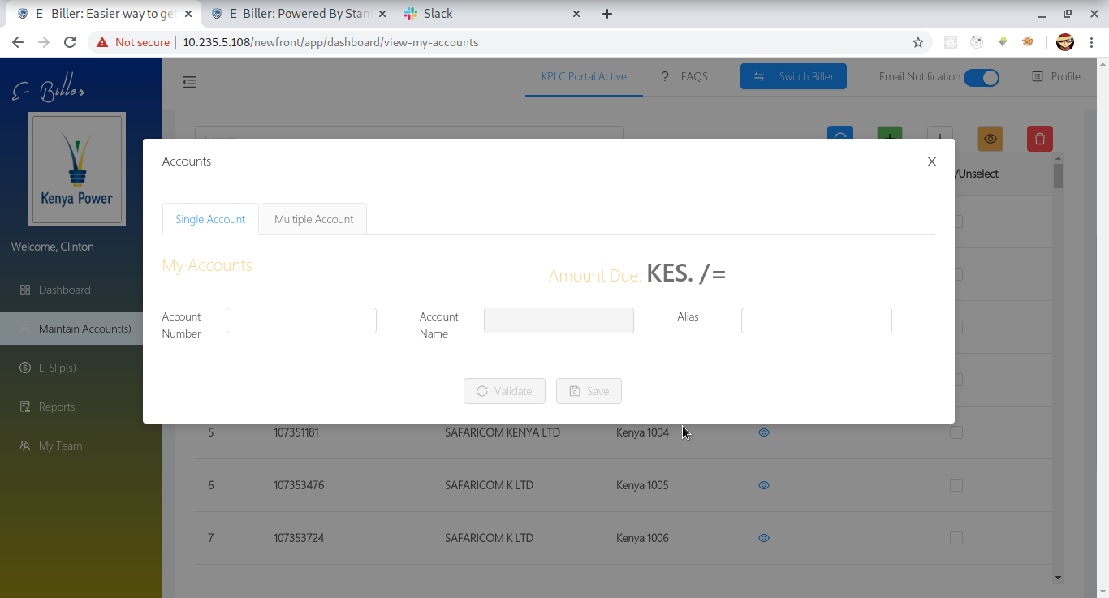

Add multiple accounts by uploading an excel file containing the accounts

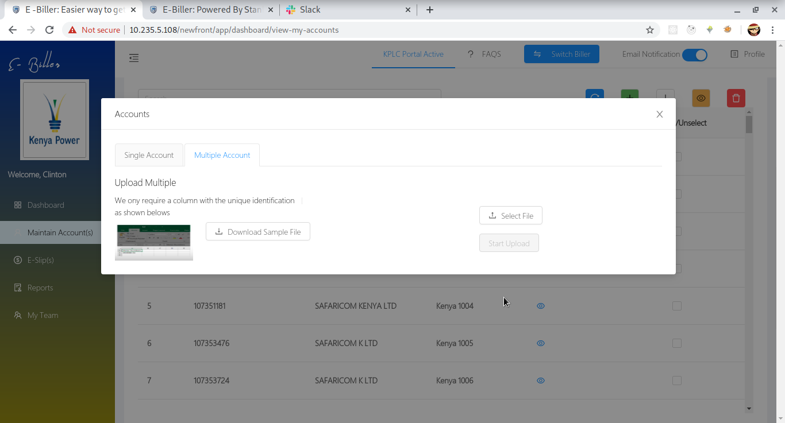

Once the upload is complete the accounts are checked if they are valid as they are added to your profile

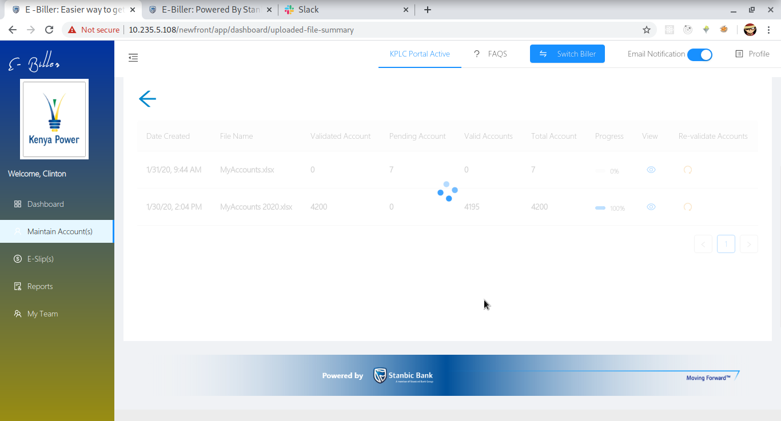

Once the percentage the upload is complete you can view the uploaded accounts or revalidate if any account failed

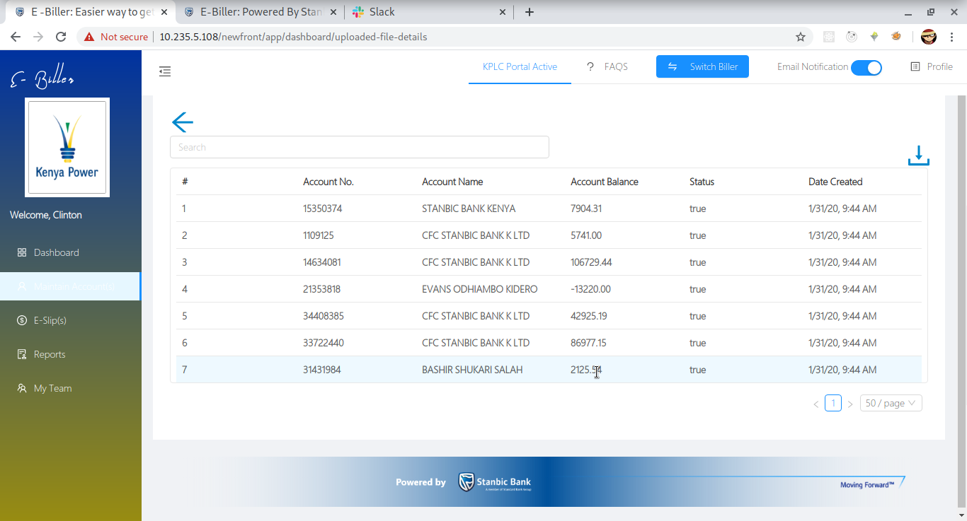

**Generate Eslip**

Eslips are generated according to the account

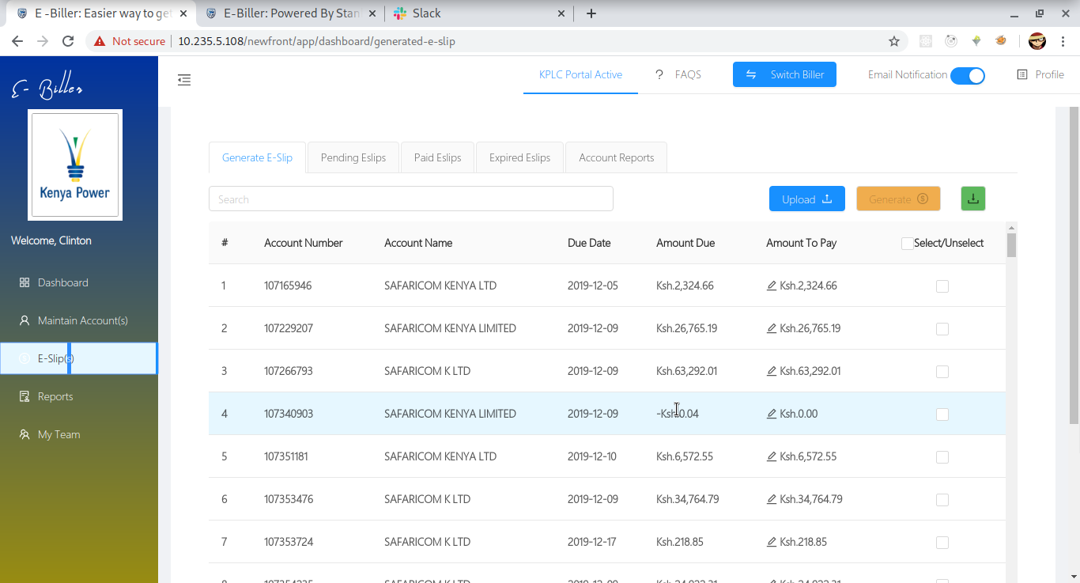

Or by uploading a payment file

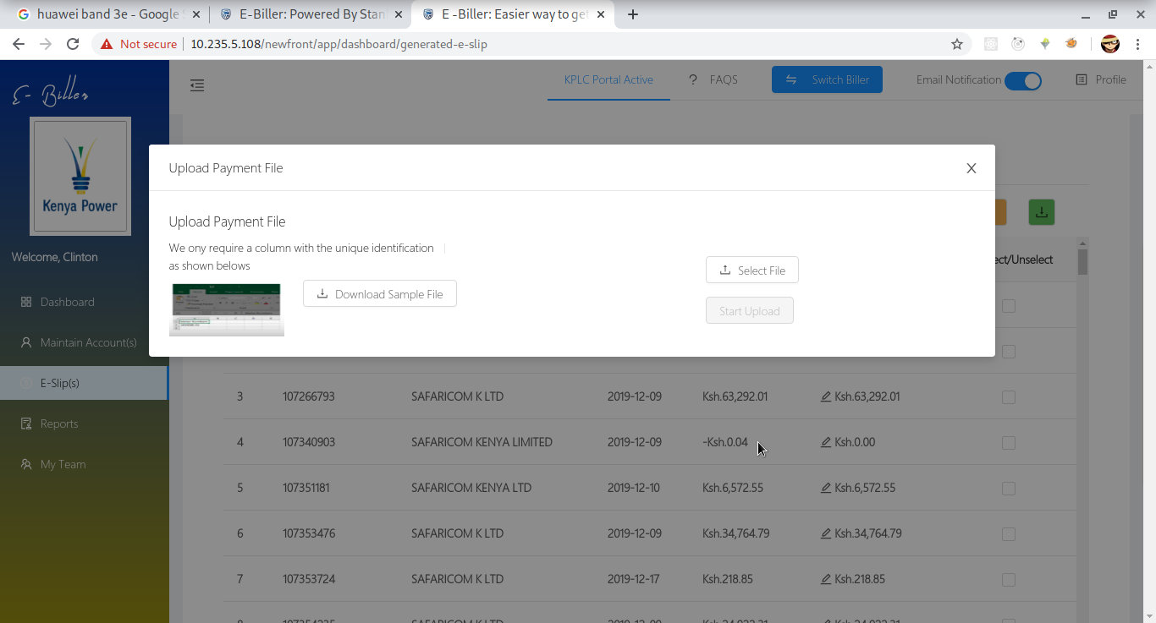

On either instance you’ll have a popup to confirm eslip generation

It will outline the number of accounts,number of valid eslips,the accounts with a zero balance and the amount to correct zero balance if any

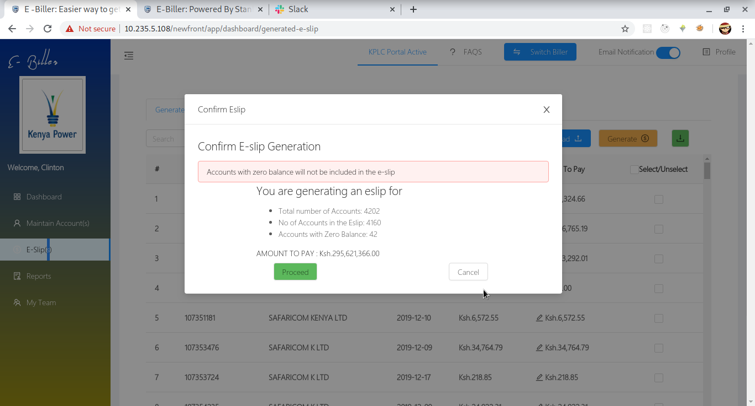

Pending eslips

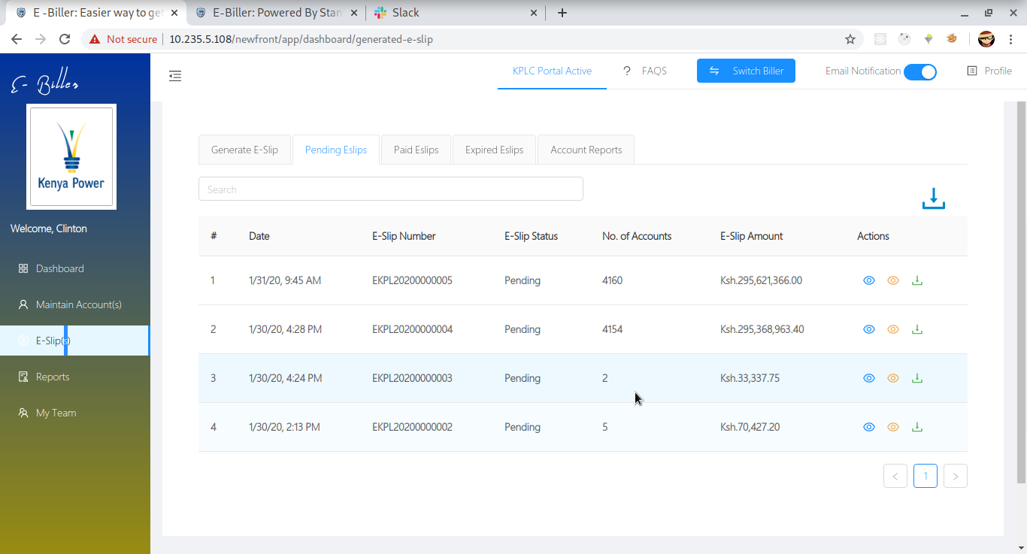

Eslip Accounts

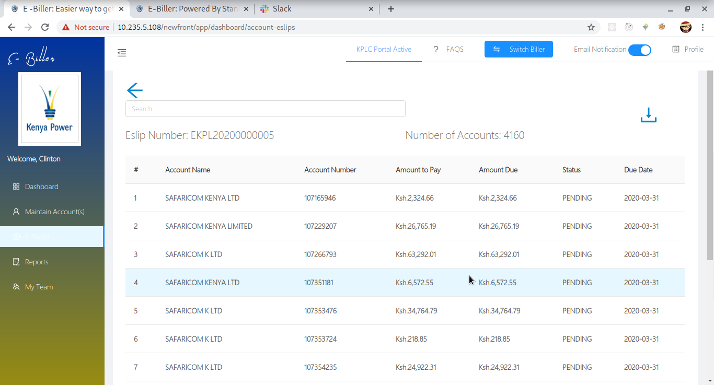

Paid Eslips

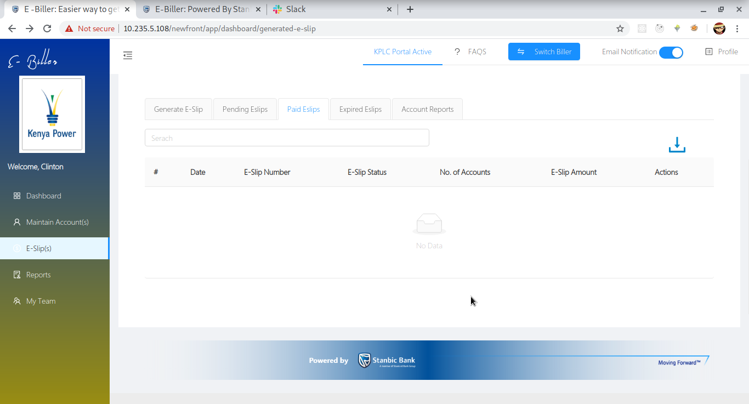

Account Reports

Summary of the accounts according to the eslip

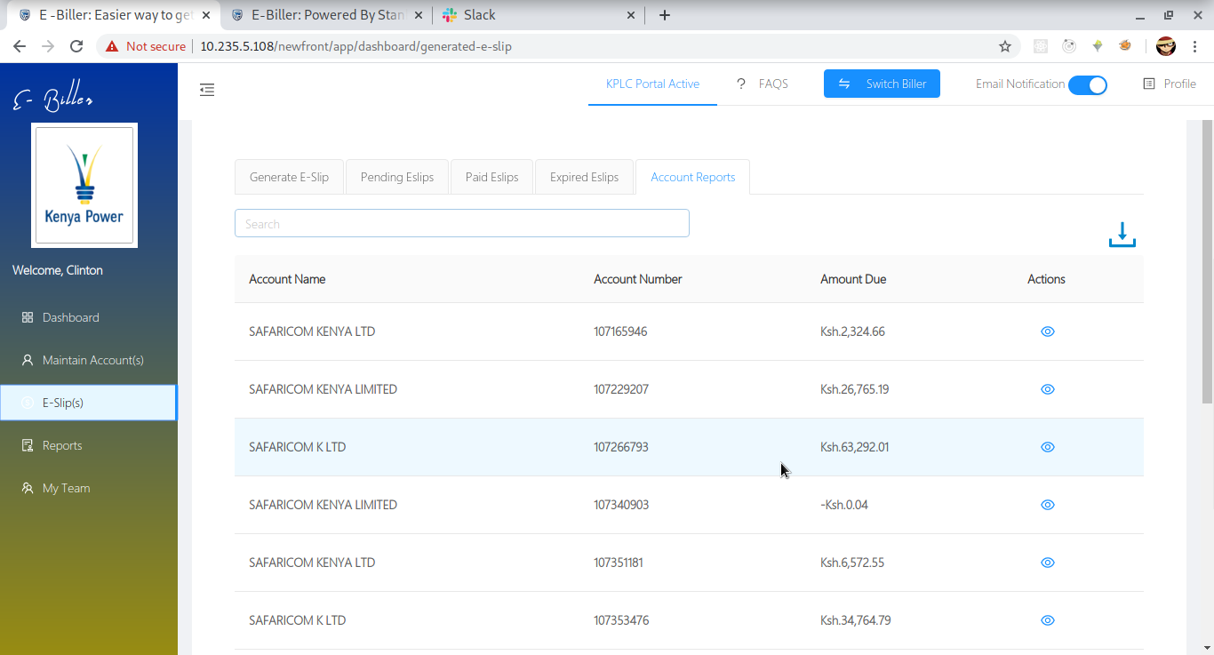

By clicking the eye icon you view a summary of the account

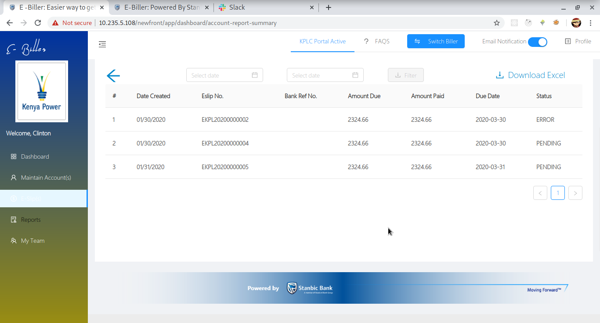

**My Team**

Team management include

* Adding a team member
* Edit a team Member
* Freeze/Lock a team member
* Create a user group
* Assign user to user group
* Edit/delete user groups

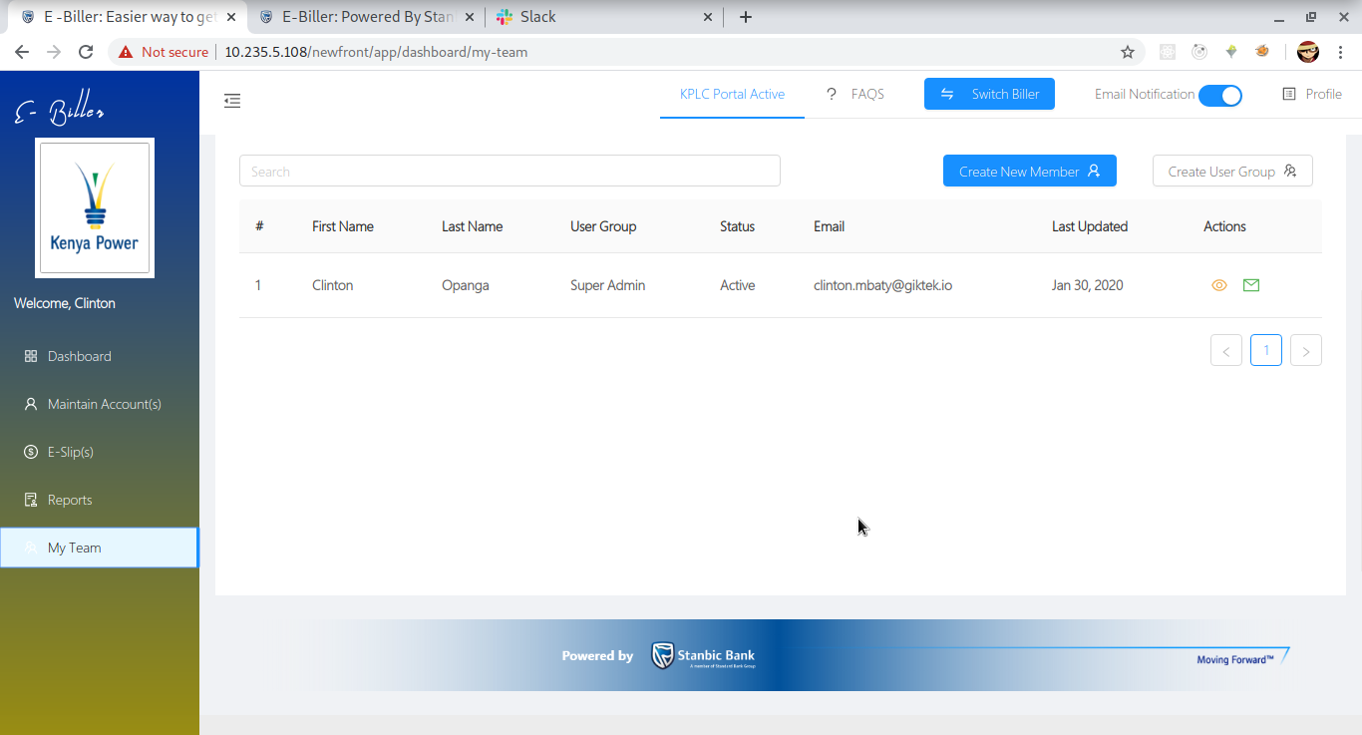

Creating a user group



Creating a team member

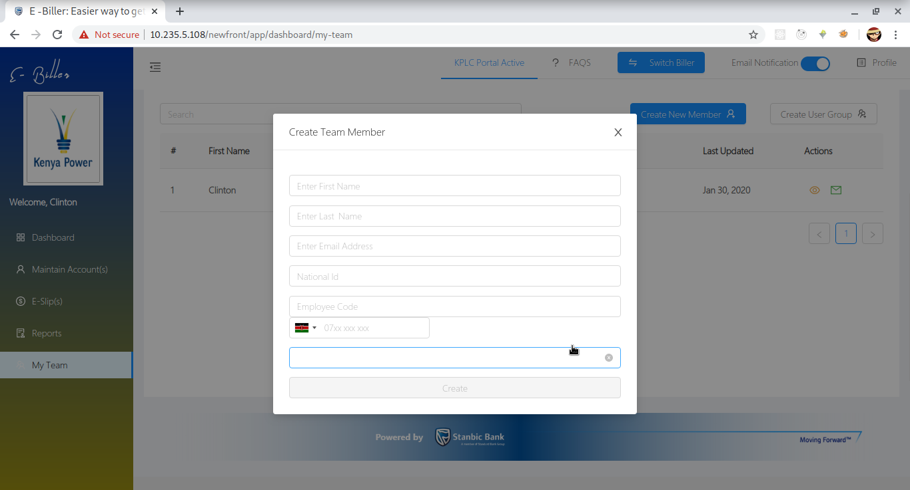

Edit team member

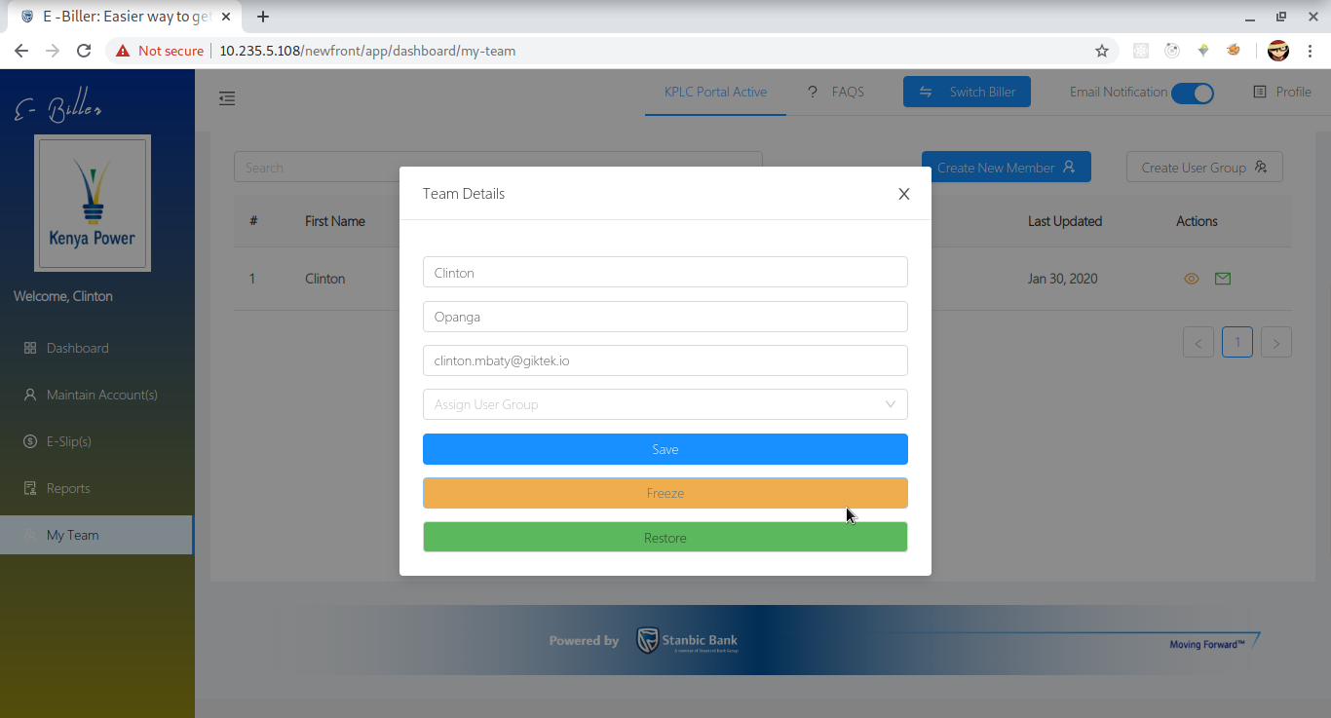

The End